**Python for Bioinformatics**

Exercise 5

**V-Title: Programs demonstrating implementation of Functions**

1.     Write a program to determine whether the number entered is Armstrong or not (should not be restricted to no. of digits)

Algorithm:-

Step 1:- The user has to enter any number.

Step 2:- Count the Number of individual digits (For Example, 370 means 3).

Step 3:- Divide the given number into individual digits (For Example, Divide 370 into 3, 7, and 0).

Step 4:- Calculate the power of n for each individual and add those numbers.

Step 5:- Compare the original value with Sum value.

Step 6:-If they exactly matched, then it is an Armstrong number else it is not Armstrong

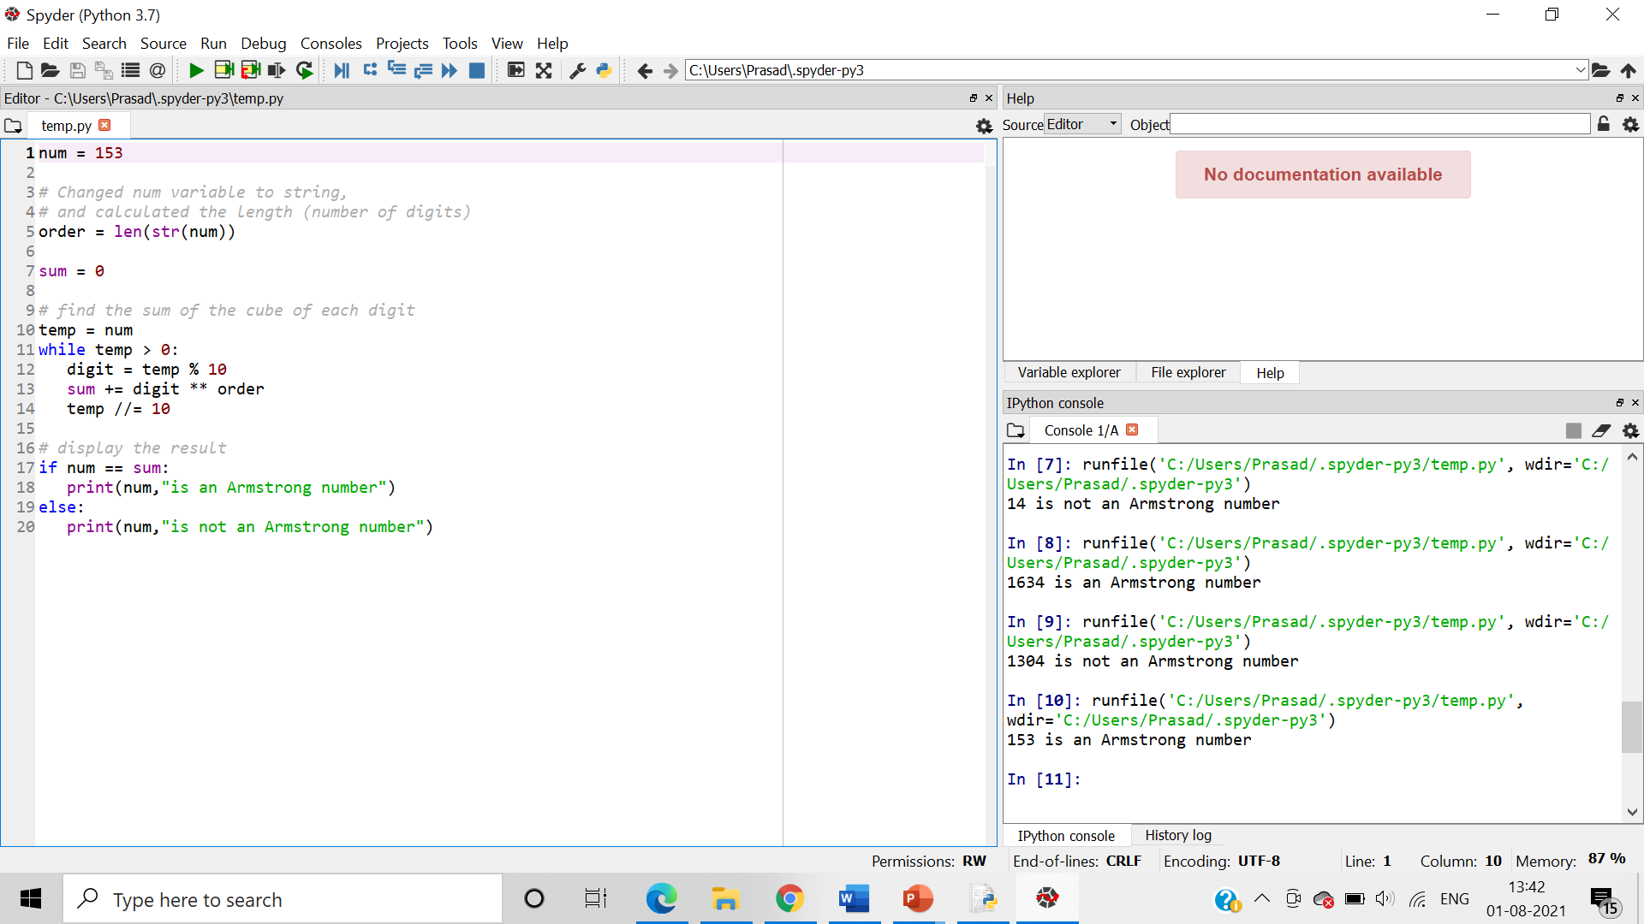

2.     Write a program to calculate the factorial of the number entered by the user (function recursion)

Algorithm:- We use recursive method to multiple all the number ranging from the input to 1 .

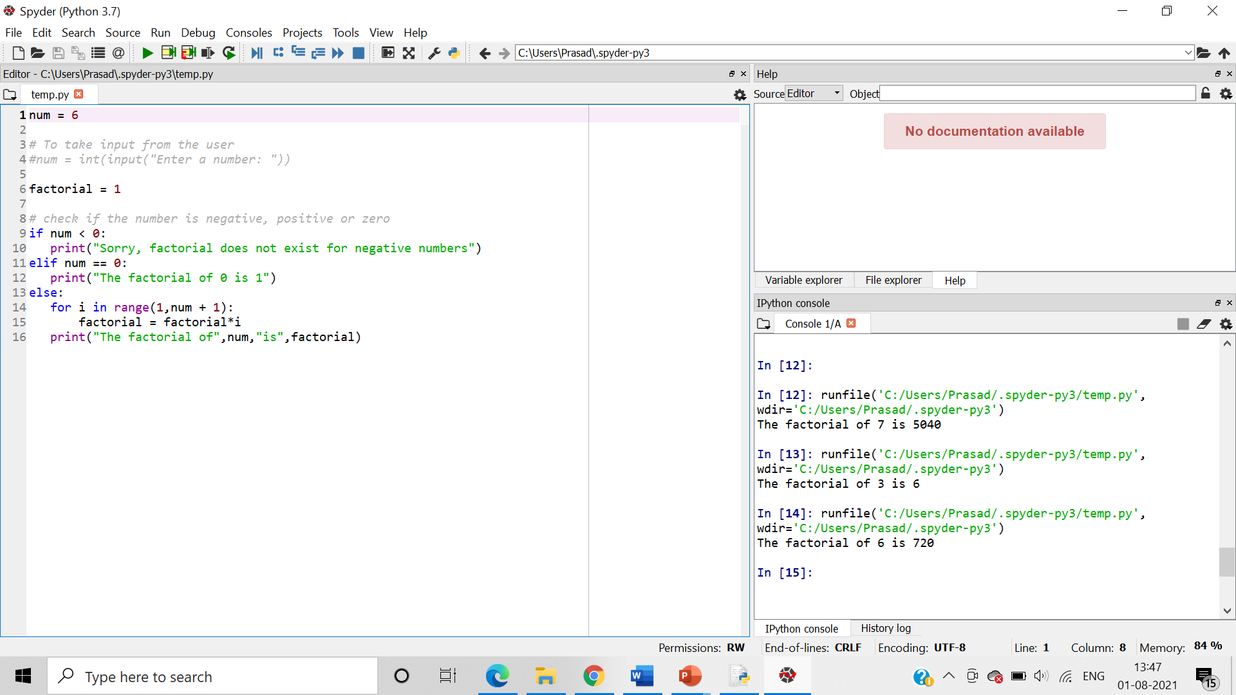

3.     Print all odd and even numbers separately entered in the user defined range (Use Lambda function)

Algorithm:-

Step 1:-Take user input.

Step 2:- If user input i.e. num%2 is equal to 0 then the num is even

Step 3:-if num%2 is not equal to 0 then it is odd.

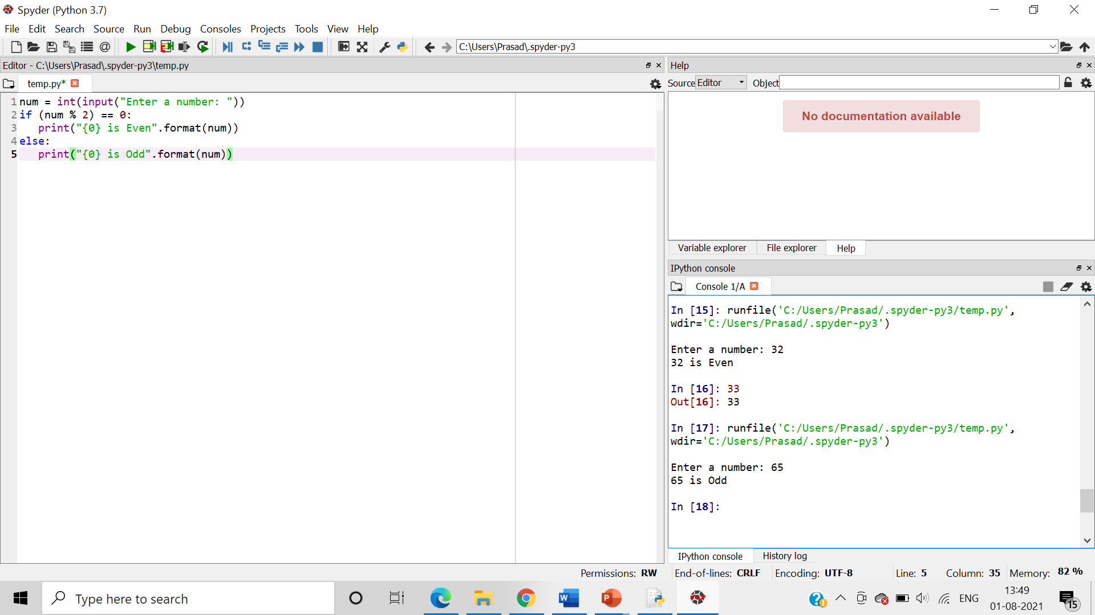

4.     Write a program to create grade calculator using dictionaries -

(Creating a dictionary which consists of the student roll no, assignment marks (4 subjects), midterm exam marks (4 subjects), final exam marks (4 subjects) and their practical results (2 subjects). Calculate the aggregate, their percentage and grades accordingly and display. Calculate the average percentage and grade of the entire class

Pooja = { "rollno”: “BID10015",

            "assignment" : [8,10,7,9],

            "midterm" : [24,26,28, 25],

            “theory” : [45,50,43,47],

            "lab" : [44, 45]

 }

5.     Write a program to calculate Molecular weight of the peptide sequence submitted by the user. Subtract the weight of water molecules.

6.     Write a program to calculate the frequency of bases in the DNA sequence submitted by the user

Algorithm:-

Step 1:-Initialize the counts of A, C, G, T to 0 and take user input.

Step 2:-Create if loop’s where if the base of the DNA sequence matches with either A, C, G, T, then their count gets incremented.

Step 3:- Print the final count of all the bases in the DNA sequence.

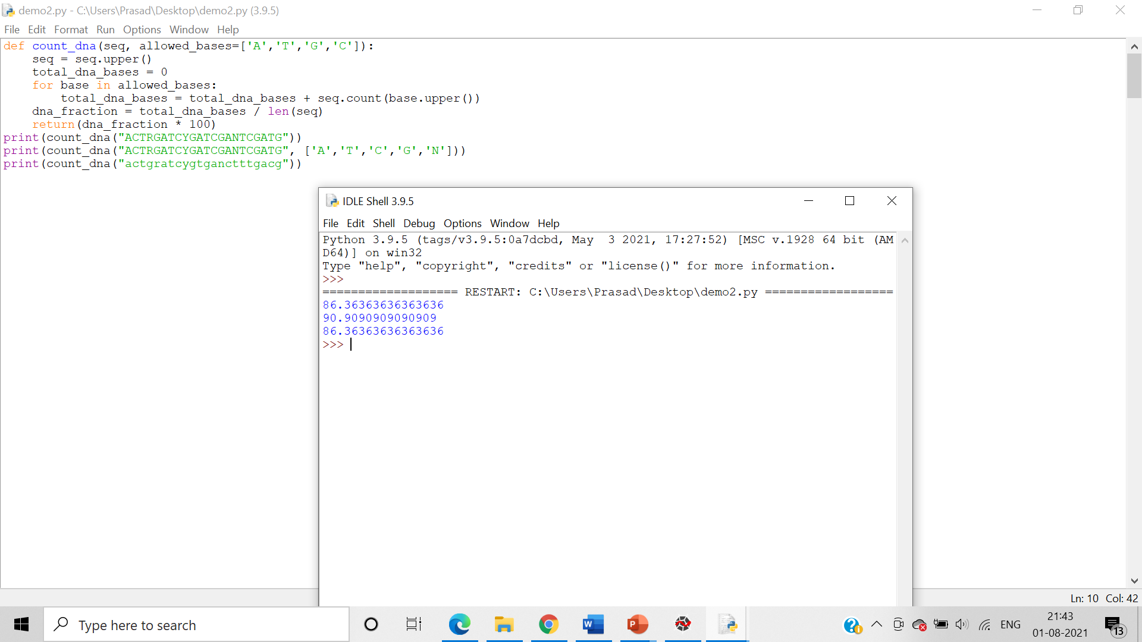

7.     Write a program to perform 1st frame [translation](http://mydy.dypatil.edu/biotech-and-bioinformatics/mod/resource/view.php?id=54882) of a dna sequence into a protein sequence.